**How to Configure Dual Layer level Server-Side encryption in Amazon S3 bucket?**

Navigate to AWS S3 console – Create a new bucket

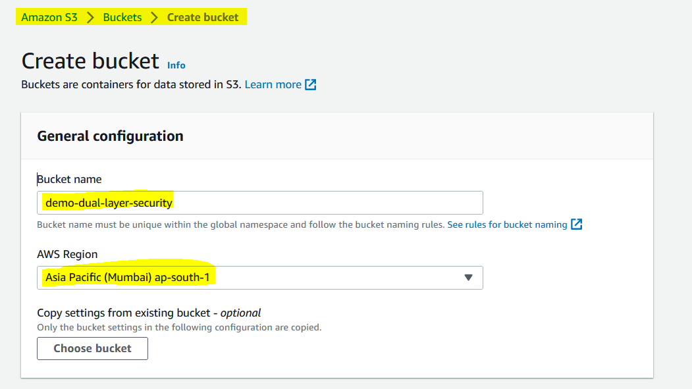

Leave as it it

Choose – Dual-layer server side encryption with Amazon Management Service Keys (DSSE-KMS)

Select – AWS KMS Key

Select – Choose from your AWS KMS Keys

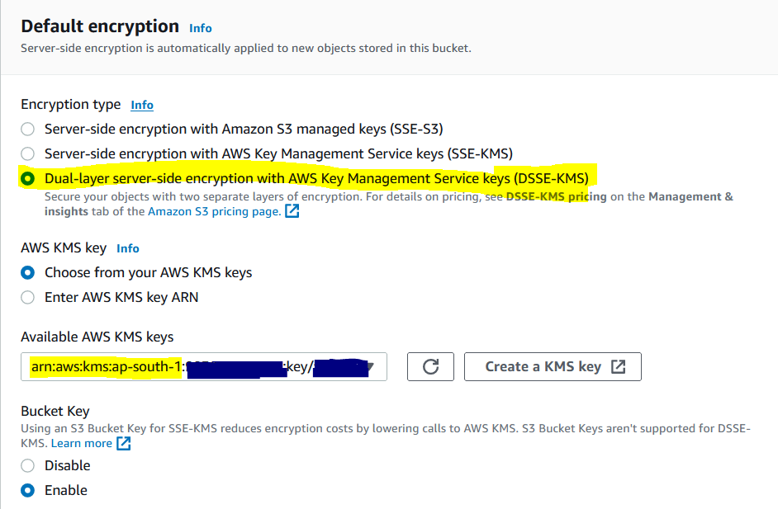

Finally Create a bucket

To upload a new object

I’m not specifying encryption key while uploading a object to S3 bucket

Encryption has been applied even I didn’t apply encryption while uploading a object to S3 bucket

To copy the object from dual-layer security bucket to another bucket(which having default server side encryption with aws-kms SSE-S3)

It’s copied successfully. But comes with same dual-layer server side encryption in destination S3 bucket

